10.1 SCIENCE 2012
ELEMENT TEST

Name: ____________________ Teacher: ___________________ Mark: /54

SECTION A: MULTIPLE CHOICE (3 marks)

Select the best answer for each question below.

1. All the elements in one period have the same number of

(a) Electrons in their first shell.
(b) Shells.
(c) Electrons in their outer shell.
(d) Protons.

2. All the elements in one group have the same number of

(a) Protons.
(b) Shells.
(c) Neutrons.
(d) Electrons in their outer shell.

3. The periodic table was first put together in 1869 by the Russian chemist

(a) Ernest Rutherford.
(b) John Newlands.
(c) Dmitri Mendeleev.
(d) Antoine Lavoisier.

SECTION B: SHORT ANSWER

1. What are the three parts that make up an atom? (3 marks)
______________________________________________________________________________________

2. How many electrons can be held in the first shell of an atom? – _______
How many electrons can be held in the second shell of an atom? – _______

How many electrons can be held in the third shell of an atom? – _______

How many electrons can be held in the fourth shell of an atom? – _______
(4 marks)

3. How many naturally occurring elements are there? ____________ (1 mark)

4. True or false – some elements have the same type of atoms as each other ____________ (1 mark)

5. The very centre of the atom is called the ________________ (1 mark)
6. Fill in the table below. (10 marks)

1 | He
2 | Be
3 | Ne
4 | O
5 | F
6 | Mg
7 | K
8 | Si
9 | C
10 | Na
11 | H
12 | Li
13 | B
14 | N
15 | Al
16 | P
17 | S
18 | Cl
19 | Ar
20 | Ca

7. What is the name given to the very outside shell of an atom? (1 mark)

_______________________________________________________________________________________

8. What are the rows in the periodic table called? _________________________________ (1 mark)

9. What are the columns in the periodic table called? ______________________________ (1 mark)

10. Explain why are symbols used for elements, instead of just element names? (2 marks)

_______________________________________________________________________________________

_______________________________________________________________________________________

11. Fill in the missing spaces. (2 marks)

Everything around us is made up of __________. We call them the building blocks because everything in the world is made up of them. An _________ cannot be seen with our __________ or even with a powerful ______________________.

12. Look at the element taken from the periodic table on the right.
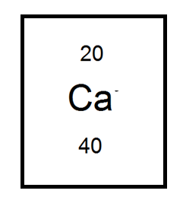
a) What is its atomic number? ______________ (1 mark)

b) What is its mass number? ________________ (1 mark)

c) How many protons are there in its nucleus? _________ (1 mark)

d) How many neutrons are there in its nucleus? _________ (1 mark)

e) What is the charge for neutrons? _________________ (1 mark)

f) What is the charge for electrons? _________________ (1 mark)

g) What is the charge for protons? __________________ (1 mark)

13. Explain why are the names of some elements so different to their symbol? For example,
they use different letters that are not even found in the name of the element! (2 marks)

_______________________________________________________________________________________

_______________________________________________________________________________________

14. a) Draw an atom in the box on the right. (0.5 marks)

b) Draw an element compound in the box on the right. (0.5 marks)

15. Draw the electron configurations for the following. Remember to write the number of protons and neutrons and use X’s to show the electrons. (6 marks)

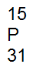
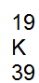
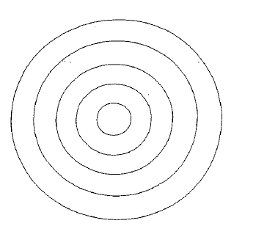

16. a) Fill in the families on the periodic table using the ones listed below. (6 marks)

Alkali metals, Alkaline earth metals, Nobel gases, Transition metals, Halogen gases, Rare earth metals.
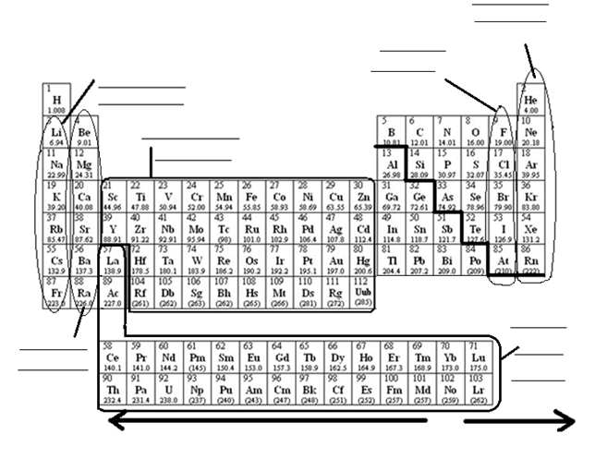

b) Look at the diagonal line, the elements touching this line have special characteristics – what is the name given to these elements?

__________________________________________ (1 mark)

c) Look at the arrows on the bottom of the periodic table. On which side would you find the metals? Left or right.

________________________________ (1 mark)

